Update – first treatment of milfoil and water lilies occurred on Monday, August 23rd

Should I pull lilies near my property?
Please hold off on pulling water lily plants until the herbicide treatment occurs.
After the two years of treatment, we will work with homeowners on weed control techniques to ensure long term eradication of water lilies.

Will all aquatic plants be treated?
No. Not all aquatic plants in the lake will be treated during this project. The WA Ecology grant funding this project allows us only to target two aquatic noxious weeds. The focus is to control two species that cause the most concern: Class B noxious weed Eurasian water milfoil (a submerged plant) and Class C noxious weed fragrant water lily (a floating-leaf plant). These are the only floating or submerged aquatic noxious weeds at the lake. All other floating and submerged plants at the lake are native plants.
Aquatic herbicides approved by the Department of Ecology will be used for the control of Eurasian water milfoil and fragrant water lilies. Herbicide treatment will be completed by a qualified, licensed contractor.
See answer to the question “Can I remove other aquatic plants myself from my waterfront?” for details on how to manage the other aquatic plants near your waterfront.

I don’t see my waterfront as a treatment area on the map. Can you treat my waterfront?
Not all aquatic plants in the lake will be treated during this project. The focus is to control the noxious weeds: Eurasian water milfoil and fragrant water lily.
If you think you have milfoil or fragrant water lilies please take a picture of the plant and send it to Ben Peterson, Chris Knutson, or Wafa Tafesh for identification.
Ben.Peterson@kingcounty.gov, Chris.Knutson@kingcounty.gov, wtafesh@kingcounty.gov
The first treatment of milfoil and water lilies occurred on Monday, August 23rd so we are not making any more changes to the treatment area.
Before treatment that will occur in 2022 another survey will be conducted, and an updated map will be sent out.

Why is the “boot” area of the lake not included?
The “boot” area of the lake has an existing herbicide permit. The City of Black Diamond worked with the Department of Ecology to keep the lake and “boot” permits separate. The permit holders for the boot will be treating milfoil this summer separate from our treatment of the rest of the lake. On our treatment map the boot area is blocked off as outside of our treatment area.

When is herbicide treatment occurring on the lake?
The target date for the first treatment for milfoil and water lilies will be Monday, August 23rd, weather permitting.
A second treatment for lilies may occur the week of September 13th.

Are there any water use restrictions or advisories?
There are no restrictions on swimming, eating fish from treated waterbodies, or using water for drinking water.
You must wait 24 hours before treated water can be used for irrigation of residential landscape, gardens, plants or lawns.
If you are withdrawing water for potable or domestic water use, livestock watering, or irrigation, and have no alternate water source, please contact Aquatechnex at 360-527-1271 to arrange an alternate water supply.

Are there any water use restrictions for pets?
Pets fall under the same water use restrictions listed above for humans.
There are no restrictions on swimming, eating fish from treated waterbodies, or using water for drinking water.
You must wait 24 hours before treated water can be used for irrigation of residential landscape, gardens, plants or lawns.

How long will it take before we see the effects of the herbicide treatment?
The first treatment for milfoil and water lilies occurred on Monday, August 23rd.
The fragrant water lilies may take about a week to start looking damaged and will probably totally die in about three weeks. Keep in mind that there will be strips of non-sprayed areas in the bigger patches. A second treatment for lilies may occur the week of September 13th.
Eurasian milfoil should start to die off within just a few days.
Keep in mind there is a multi-year effort. Another treatment event is being planned for summer of 2022.

Can I remove other aquatic plants myself from my waterfront?
Yes. Without an herbicide permit you can do hand cutting or removal yourself if you follow the instructions in the WDFW Aquatic Plants and Fish pamphlet permit: Aquatic Plants and Fish: Rules for Aquatic Plant Removal and Control (2015) | Washington Department of Fish & Wildlife.
To “obtain” the permit all you need to do is print a copy and have it physically with you when working to remove aquatic plants. There are various restrictions on the kind of tools you can use and area limitations so make sure you read and understand the permit entirely. From the permit, table 1 below summarizes the overall permit requirements. Note that the rules vary depending if the plant is a listed Aquatic Noxious Weed (Noxious week lists and laws – King County) or an Aquatic Beneficial Plant (native plants and non-noxious weed non-native plants).
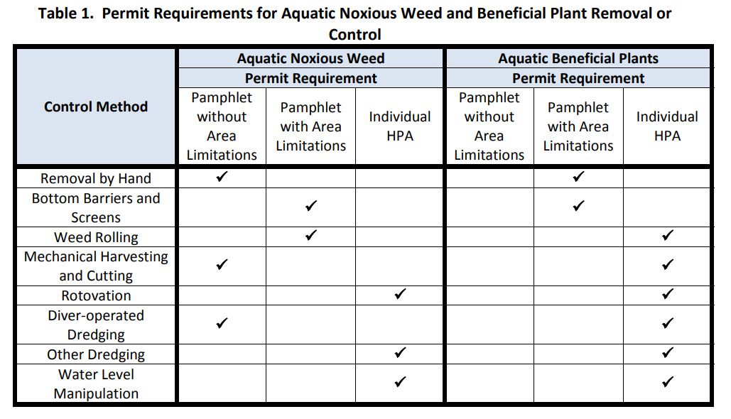
Milfoil spreads by fragmentation so please pick up all plant parts that break free if you go the hand removal route. And please hold off on pulling water lily plants until the herbicide treatment occurs.

